MA-09
2016 IE Strategy Memorandum

Updated on 4/18/16

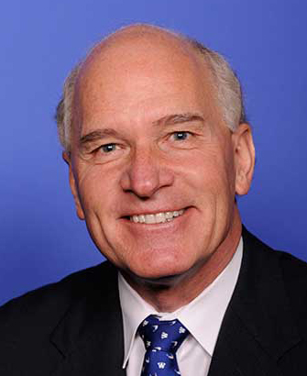



WILLIAM KEATING TOM O’MALLEY
CoH: $486,327.50 CoH: $5,005.21
Date: 4/15/16 Date: 4/15/16
Occupation: Congressman Occupation: Navy Pilot (ret) Commercial Pilot


MAERK ALLIEGRO
CoH: $61,235
Date: 4/15/16
Occupation: Professor/Biologist

SECTION I: Race Overview
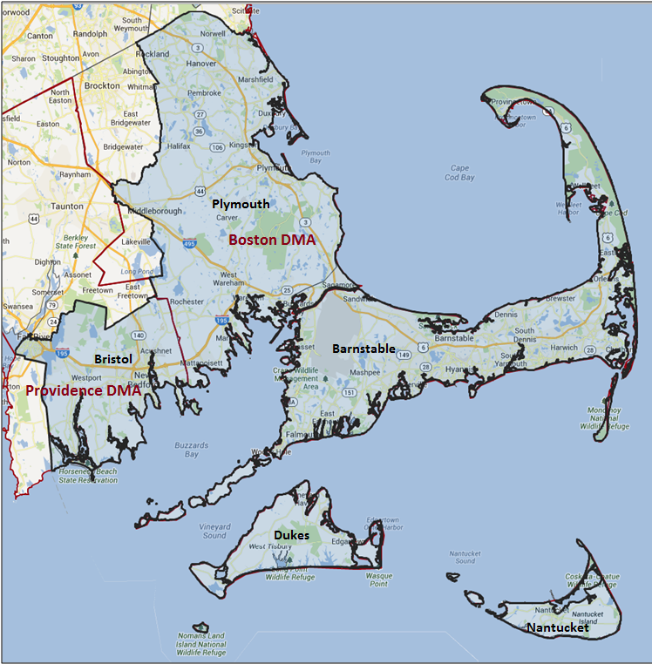
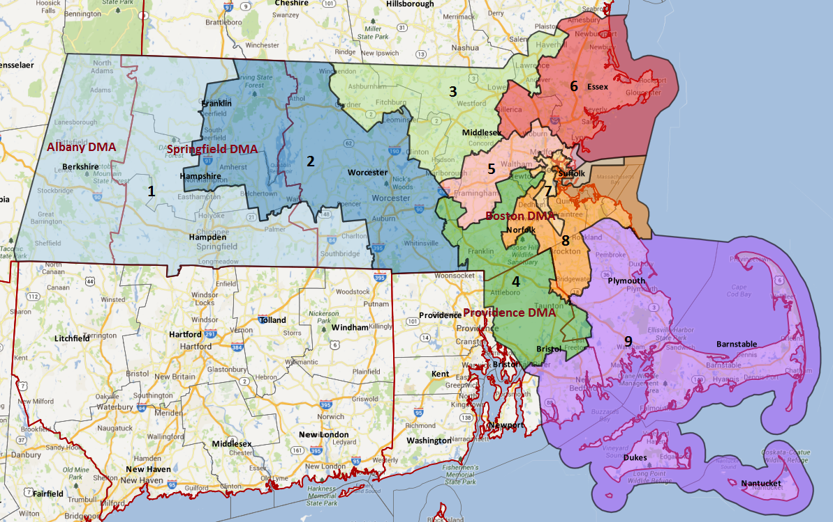

Media Market Costs

TV DMA | % of  CD | I.E.  35+ CPP | Cable CPP
BOSTON | 74% | $810
PROVIDENCE-NEW BEDFORD | 26% | $243
MA-09 TOTALS: | 100.0%
Digital Landscape
  - Persuasion universe size: 78,901
  - Audience extension (key demos): Independents & Democrats
  - Weekly budget for full coverage: $21,382.25
  - Reach
    - YouTube - 363,545
    - Pandora - 178,419

Presidential Statistics
Cycle | Candidate | Party | Vote
2012 | Obama | DEM | 56.2%
2012 | Romney | REP | 43.8%
2008 | Obama | DEM | 58.7%
2008 | McCain | REP | 41.3%

Congressional Statistics
Cycle | W/L | Candidate | Party | Vote
2014 | W | KEATING | DEM | 54.9%
2014 | L | CHAPMAN | REP | -
2012 | W | KEATING | DEM | 64.6%
2012 | L | SHELDON | REP | 35.4%

NCEC Data
Dem Performance: 52.5%
BVAP: 2.3%
Hispanic: 3.1%
Asian: 1%
Total Minority: 6.4%

Critical Dates
Filing Date: February 16th, 2016
Primary Date: Sept. 20th, 2016

Pre-Election Day Voting

Type of  “Early Voting” | Start Date  End Date | Percent of  Vote Cast Using this Method | Brief Description  (where/how  do people vote) | Timeframe (when does the majority of voting happen)
VBM Absentee Ballot/In person Absentee | In-person absentee voting starts as soon as printed absentee ballots are available. You can apply for and vote your absentee ballot during the same visit to your Local Election Official. |  | Voters must apply for an absentee/VBM ballot via mail, online, or in person

